Arcade Machine Research

15mm Plywood Sheets Cut to Size up to 200 cm Length multiplex Board cuttings: 20x100 cm

---- <https://www.amazon.co.uk/Plywood-Sheets-length-multiplex-cuttings/dp/B0742BBSCC>

**Tutorial for Building**

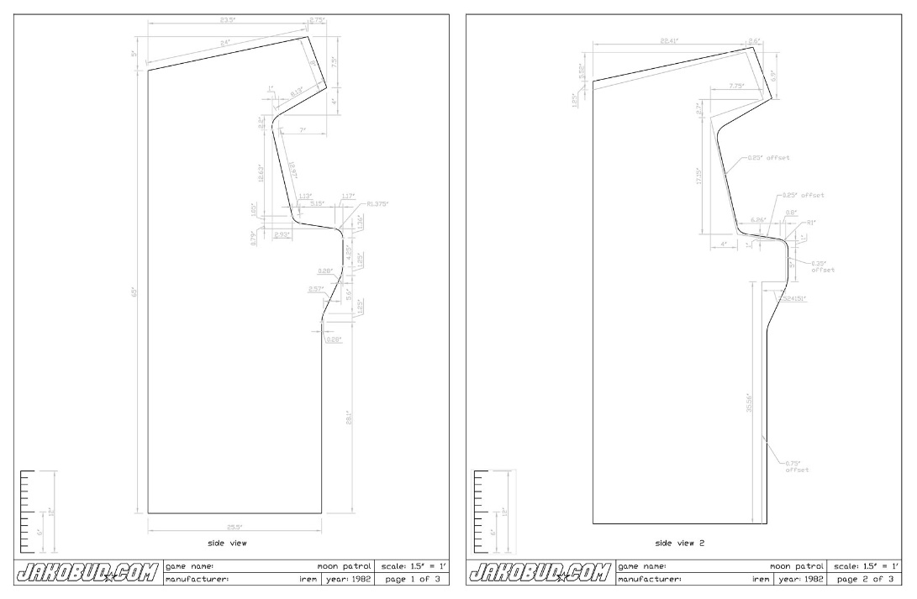http://retromash.com/2016/05/01/building-a-home-arcade-machine-part-7-cabinet-plans/